Spring has a view resolver. Using controller we return a string. And then view resolver maps it to the original view file. For ex: result.jsp
By default this view resolver looks for the file in webapp, but if we want to change the file destination we can do that by declaring our path(prefix) in application.properties file inside of resource.
We can also declare the suffix here, meaning from the controller we can just simply return “result”, then it will automatically get mapped to result.jsp.
We can get this properties from google itself, no need to memorize it.

@RequestMapping("/")
public String home(){
return "index" ;
}
We are returning only index not index.jsp
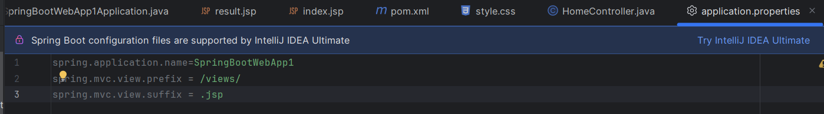
We are keeping index.jsp and result.jsp inside views folder under webapp folder

